Prudential Standard CPS 511 Remuneration Disclosures for Deutsche Bank AG Sydney Branch

Performance Year 2024

Introduction
This document is published by Deutsche Bank Australia (DBA) as required by the Australian Prudential Regulation Authority’s (APRA) Prudential Standard CPS 511 – Remuneration (CPS 511). DBA’s remuneration framework and practices are consistent with those of the Deutsche Bank Group globally. For the purposes of CPS 511, DBA is a foreign Authorised Deposit Taking Institution in Australia and a Non-Significant Financial Institution. This document is published to fulfil the disclosure requirements of CPS 511, and outlines key information regarding Deutsche Bank’s global compensation framework and additional Australia-specific information.

Regulatory Environment
Ensuring compliance with regulatory requirements is an overarching consideration in Deutsche Bank’s Group Compensation Strategy. The bank strives to be at the forefront of implementing regulatory requirements with respect to compensation and will continue to maintain a close exchange with its prudential supervisor, the European Central Bank (ECB), to be in compliance with all existing and new requirements.
As an EU-headquartered institution, Deutsche Bank is subject to the Capital Requirements Regulation/Directive (CRR/CRD) globally, as transposed into German national law in the German Banking Act and Institutsvergütungsverordnung (InstVV). These rules are applied to all Deutsche Bank subsidiaries and branches world-wide to the extent required in accordance with Section 27 InstVV. As a Significant Institution within the meaning of the German Banking Act, Deutsche Bank identifies all employees whose work is deemed to have a material impact on the overall risk profile (Material Risk Takers or MRTs) in accordance with the criteria stipulated in the German Banking Act and in the Commission Delegated Regulation 2021/923. MRT identification is performed for Deutsche Bank Group as well as for institutions in the EU at institutional level.
As noted, in addition to InstVV, DBA is also subject to CPS 511. The majority of the requirements of CPS 511 are aligned with InstVV.

Specified Roles
For CPS 511 purposes, DBA has assessed that those in Specified Roles for DBA comprise:

Senior Managers
Those in the roles of: (i) the Senior Officer Outside Australia (SOOA), (ii) the CEO of DBA, (iii) the Branch Managers of DBA, (iv) DBA’s Responsible Persons under APRA Prudential Standard CPS 520 - Fit and Proper, and (v) DBA’s Accountable Persons under the Financial Accountability Regime Act 2023. Some individuals hold multiple such roles.

Material Risk Takers – CPS 511
On a global basis, the bank identifies Material Risk Takers (MRTs) according to CRD/InstVV requirements. Additionally, DBA conducts a separate local assessment of Material Risk Taker roles as defined in CPS 511 (CPS 511 MRTs). Accordingly, DBA has determined that the following roles are identified as CPS 511 MRT roles: (i) certain Senior Manager roles for DBA, and (ii) globally identified MRTs in business units in Australia that carry significant levels of market and credit risk.

Risk and Financial Control Personnel
Individuals working in the Country Finance, Risk, Compliance and Audit departments in Australia are included in this group.

Compensation Governance
Deutsche Bank has a robust governance structure enabling it to operate within the clear parameters of its Compensation Strategy and Policy. In accordance with the German two-tier board structure, the Supervisory Board governs the compensation of the Management Board members while the Management Board oversees compensation matters for all other employees in the Group. Both the Supervisory Board and the Management Board are supported by specific committees and functions, in particular the Compensation Control Committee (CCC), the Compensation Officer, and the Senior Executive Compensation Committee (SECC).
In line with their responsibilities, the bank’s control functions as per InstVV are involved in the design and application of the bank’s remuneration systems, in the identification of MRTs and in determining the total amount of Variable Compensation. This includes assessing the impact of employees’ behavior and the business-related risks, performance criteria, granting of remuneration and severances as well as ex-post risk adjustments.
Reward governance structure
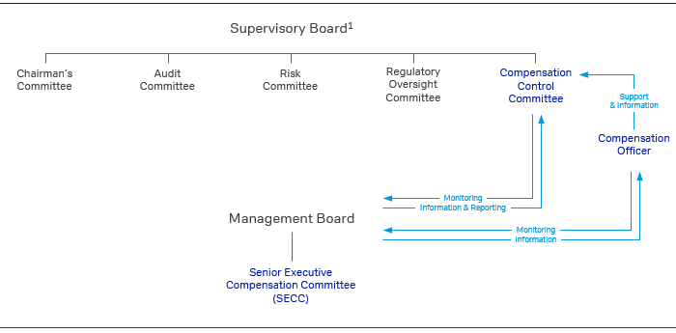
¹ Does not comprise a complete list of Supervisory Board Committees

Compensation Control Committee (CCC)
The Supervisory Board has set up the CCC to support in establishing and monitoring the structure of the compensation system for the Management Board Members of Deutsche Bank AG. Furthermore, the CCC monitors the appropriateness of the compensation systems for the employees of Deutsche Bank Group, as established by the Management Board and the SECC. The CCC reviews whether the total amount of variable compensation is affordable and set in accordance with the risk, capital and liquidity situation as well as in alignment with the business and risk strategies. Furthermore, the CCC supports the Supervisory Board in monitoring the bank’s MRT identification process. It held 6 meetings in total for the performance year 2024.

Compensation Officer
The Management Board, in cooperation with the CCC, has appointed a Group Compensation Officer to support the Supervisory Boards of Deutsche Bank AG and of the bank’s Significant Institutions in Germany in performing their compensation related duties. The Compensation Officer is involved in the conceptual review, development, monitoring and application of the employees’ compensation systems, the MRT identification and remuneration disclosures on an ongoing basis. The Compensation Officer performs all relevant monitoring obligations independently, provides an assessment on the appropriateness of the design and strategy of the compensation systems for employees at least annually and regularly supports and advises the CCC.

Senior Executive Compensation Committee (SECC)
The SECC is a delegated committee established by the Management Board which has the mandate to develop sustainable compensation principles, to prepare recommendations on Total Compensation levels and to ensure appropriate compensation governance and oversight. The SECC establishes the Compensation and Benefits Strategy, Policy and corresponding guiding principles. Moreover, using quantitative and qualitative factors, the SECC assesses Group and divisional performance as a basis for compensation decisions and makes recommendations to the Management Board regarding the total amount of annual variable compensation and its allocation across business divisions and infrastructure functions.
In order to maintain its independence, only representatives from infrastructure and control functions who are not aligned to any of the business divisions are members of the SECC. In 2024, the SECC’s membership comprised of the DB AG Management Board member responsible for Human Resources and the Chief Financial Officer as Co-Chairpersons, the Head of Compliance, the Head of Human Resources and the Head of Performance & Reward as well as an additional representative from both Finance and Risk as voting members. The Compensation Officer and an additional representative from Finance participated as non-voting members. The SECC generally meets on a monthly basis but with more frequent meetings during the compensation determination process. It held 19 meetings in total with regard to the compensation process for the performance year 2024.

Senior Officer Outside Australia (SOOA)
All employees in Australia are subject to the global Deutsche Bank compensation framework and remuneration governance policies and practices, that are designed to comply with the European CRD/InstVV remuneration regulations. To comply with CPS 511, the SOOA fulfils an additional oversight role and is satisfied that the global framework substantially fulfills CPS 511 requirements. Annually, or after any significant changes, the SOOA reviews and approves relevant remuneration policy documentation. The SOOA also has oversight of and contributes to the annual compensation decision making processes for Australia and assesses compensation proposals for those in Specified Roles.

Compensation and Benefits Strategy

Deutsche Bank recognises that its compensation framework plays a vital role in supporting its strategic objectives. It enables the bank to attract and retain the individuals required to achieve the bank’s objectives. The Compensation and Benefits Strategy is built on three core pillars (Principles, Performance and Processes as outlined below) that support the bank’s global, client-centric business and risk strategy, reinforced by safe and sound compensation practices that operate within the bank’s profitability, solvency and liquidity position.
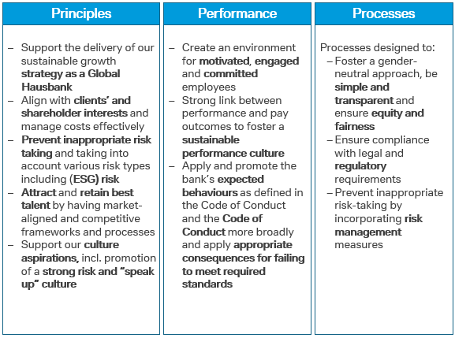

Group Compensation Framework
The compensation framework, generally applicable globally across all regions and business lines, emphasises an appropriate balance between Fixed Pay (FP) and Variable Compensation (VC) – together forming Total Compensation (TC). It aligns incentives for sustainable performance at all levels of Deutsche Bank whilst ensuring the transparency of compensation decisions and their impact on shareholders and employees. The underlying principles of Deutsche Bank’s Compensation Framework are applied to all employees equally and are supported by the key principle ‘equal pay for equal work or work of equal value’ and the necessity for equal opportunities, irrespective of differences in, e.g., tenure, gender or ethnicity.
Pursuant to CRD and the requirements subsequently adopted in the German Banking Act, Deutsche Bank is subject to a maximum ratio of 1:1 with regard to fixed-to-variable remuneration components, which was increased to 1:2 for a limited population with shareholder approval on May 22, 2014 with an approval rate of 95.27%, based on valid votes by 27.68% of the share capital represented at the Annual General Meeting. Control Functions as defined by InstVV, comprising Risk, Compliance and Anti-Financial Crime, Group Audit and the Group Compensation Officer and his Deputy, are subject to a maximum ratio of 2:1. Employees in certain infrastructure functions should continue to be subject to a maximum ratio of 1:1.
With effect from 2024 the bank amended and simplified its compensation framework by ensuring all employees are eligible for individual VC, by incorporating the former Group VC Component into the overall VC pool determination, and by removing both Reference Total Compensation and Recognition Awards. To maintain an appropriate balance between FP and VC, the bank implemented a more standardised VC orientation concept with orientation values based on division, profession and seniority that indicate the average expected VC as a percentage value of FP.
Fixed Pay is the key and primary compensation element for most employees globally. It is a fixed regular payment based on transparent and predetermined conditions. It is delivered either in the form of base salary and where applicable local specific fixed pay allowances. Fixed Pay reflects the value of the individual role and function within the organisation, regional and divisional specifics and rewards the factors an employee brings to the organisation such as qualification, skills and experience required for the role in line with remuneration levels in the specific geographic location and level of responsibility.
Variable Compensation is a discretionary compensation component that reflects Group, Divisional risk-adjusted financial and non-financial performance as well as individual contributions. It acknowledges that employees contribute towards the success of their Division and the Group as a whole. At the same time, VC allows the bank to differentiate individual contributions and to drive behavior and conduct through an incentive system that can positively influence culture and the achievement of the bank’s strategic objectives and to apply consequences for falling below the standards of delivery, behavior and conduct by reducing the VC.
Employee benefits are considered FP from a regulatory perspective, as they have no direct link to performance or discretion. They are granted in accordance with applicable local market practices and requirements. Pension expenses represent the main element of the bank’s benefits portfolio globally.
Total Compensation (TC) is made up of defined Fixed Pay, Variable Compensation and is supplemented by benefits.

Determination of Performance-based Variable Compensation
The bank puts a strong focus on its governance related to compensation decision-making processes. A robust set of rule-based principles for compensation decisions with close links to the performance of both businesses and individuals were applied.
The total amount of VC for any given performance year is derived from an assessment of the bank’s profitability, solvency, and liquidity position (affordability assessment), Group performance and the performance of divisions and infrastructure functions in support of achieving the bank’s strategic objectives.
In a first step, Deutsche Bank assesses the bank’s affordability as well as other limitations (such as cost constraints) to determine what the bank “can” award in line with regulatory and internal requirements. In the next step, the bank assesses divisional risk-adjusted performance, i.e. what the bank “should” award in order to provide an appropriate compensation for contributions to the bank’s success. The proportion of the VC pools related to Group performance, which has a weighting of 25%, is determined based on the performance of a selected number of Group’s Key Performance Indicators (KPIs), including Common Equity Tier 1 (CET 1) Capital Ratio, Cost/Income Ratio (CIR), Post-Tax Return on Tangible Equity (RoTE), ESG: Environmental - Sustainable Financing and ESG Investments, Social - Gender Diversity and Governance - Audit Control Risk Management Grade.
When assessing divisional performance, a range of considerations are referenced. Performance is assessed in the context of financial and – based on Balanced Scorecards – non-financial targets. The financial targets for front-office divisions are subject to appropriate risk-adjustment, in particular by referencing the degree of future potential risks to which Deutsche Bank may be exposed, and the amount of capital required to absorb severe unexpected losses arising from these risks. For the infrastructure functions, the financial performance assessment is mainly based on the achievement of cost targets. While the allocation of VC to infrastructure functions, and in particular to control functions, depends on both Deutsche Bank’s overall and their own performance, it is not dependent on the performance of the division(s) that these functions oversee.
At the level of the individual employee, the VC Guiding Principles are established, which detail the factors and metrics that managers need to take into account when making VC decisions. In doing so, they must fully appreciate the risk-taking activities of individuals to ensure that VC allocations are balanced and risk-taking is not inappropriately incentivised. The factors and metrics to be considered include, but are not limited to, (i) business delivery (“What”), i.e. quantitative and qualitative financial, risk-adjusted and non-financial performance metrics, and (ii) behavior (“How”), i.e. culture, conduct and control considerations such as qualitative inputs from control functions or disciplinary sanctions. VC setting recommendations help managers to translate individual performance (“What” and “How”) into appropriate pay outcomes. Generally, performance is assessed based on a one-year period.

Variable Compensation Structure
The compensation structures are designed to provide a mechanism that promotes and supports long-term performance of employees and the bank. Whilst a portion of VC is paid upfront, these structures require that an appropriate portion is deferred to ensure alignment to the sustainable performance of the Group. For both parts of VC, Deutsche Bank shares are used as instruments and as an effective way to align compensation with Deutsche Bank’s sustainable performance and the interests of shareholders.
The bank continues to go beyond regulatory requirements with the scope as well as the amount of VC that is deferred and the minimum deferral periods for certain employee groups. The deferral rate and period are determined based on the risk categorisation of the employee as well as the business unit. Where applicable, the bank starts to defer parts of variable compensation for MRTs where VC is set at or above € 50,000 or where VC exceeds 1/3 of TC. For non-MRTs, deferrals start at higher levels of VC. MRTs are on average subject to deferral rates in excess of the minimum 40% (60% for Senior Management) as required by InstVV. For MRTs in Material Business Units (MBU) the bank applies a deferral rate of at least 50%. The VC threshold for MRTs requiring at least 60% deferral is set at € 500,000. Moreover, for all employees whose FP exceeds the amount of € 500,000, the full amount of the VC is deferred.
The award types and deferral rates detailed below apply also to all DBA employees, including those in Specified Roles under CPS 511, as applicable.
As detailed in the table below, deferral periods range from three to five years, dependent on employee groups.
Overview of 2024 award types
Award Type |  | Description |  | Beneficiaries |  | Deferral Period |  | Retention Period |  | Portion
Upfront:  Cash VC |  | Upfront cash |  | All eligible employees |  | N/A |  | N/A |  | 100% of VC, except employees with deferred awards
Upfront:  Equity Upfront Award (EUA) |  | Upfront equity (linked to Deutsche Bank’s share price over the retention period) |  | MRTs with VC ≥ € 50,000 or where VC exceeds 1/3 of TC  Non-MRTs with deferred awards where 2024 TC >  € 500,000 |  | N/A |  | 12 months |  | 50% of upfront VC
Deferred:  Restricted Incentive Award (RIA) |  | Deferred cash |  | All employees with deferred VC |  | Equal tranche vesting:  MRTs: 4 years  Senior Mgmt.¹: 5 years  Non-MRTs: 3 years |  | N/A |  | 50% of deferred VC
Deferred:  Restricted Equity Award (REA) |  | Deferred equity (linked to Deutsche Bank’s share price over the vesting and retention period) |  | All employees with deferred VC |  | Equal tranche vesting:  MRTs: 4 years  Senior Mgmt.¹: 5 years  Non-MRTs: 3 years |  | 12 months for MRTs |  | 50% of deferred VC
N/A – Not applicable
¹ For the purpose of Performance Year 2024 annual awards, Senior Management is defined DB AG MB-1 positions; incumbents of MB-2 positions in IB and CB reporting to Head of CB and Co-Heads of IB; further individuals with significant business responsibilities; MB members of Significant Institutions in the meaning of the German Banking Act; respective MB-1 positions with managerial responsibility; for the specific deferral rules for the Management Board of Deutsche Bank AG refer to the Compensation Report for the Management Board
Employees are not allowed to sell, pledge, transfer or assign a deferred award or any rights in respect to the award. They may not enter into any transaction having an economic effect of hedging any variable compensation, for example offsetting the risk of price movement with respect to the equity-based award. The Human Resources and Compliance functions, overseen by the Compensation Officer, work together to monitor employee trading activity and to ensure that all employees comply with this requirement.

Ex-post Risk Adjustment of Variable Compensation
In line with regulatory requirements relating to ex-post risk adjustment of variable compensation, the bank believes that a long-term view on conduct and performance of its employees is a key element of deferred VC. As a result, under the Management Board’s oversight, all deferred awards are subject to performance conditions and forfeiture provisions as detailed below.
Overview on Deutsche Bank Group performance conditions and forfeiture provisions of variable compensation granted for Performance Year 2024
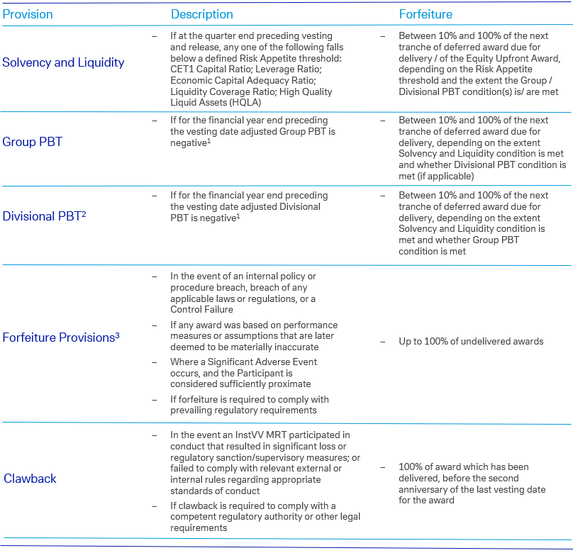
¹ Considering clearly defined and governed adjustments for relevant Profit and Loss items (e.g., business restructurings; impairments of goodwill or intangibles)
² Only applicable to InstVV MRTs in front office divisions
³ Other provisions may apply as outlined in the respective plan rules

Compensation Decisions for 2024
All compensation decisions are made within the boundaries of regulatory requirements. These requirements form the overarching framework for determining compensation at Deutsche Bank. In particular, management must ensure that compensation decisions are not detrimental to maintaining the bank’s sound capital base and liquidity reserves.
In 2024, Deutsche Bank successfully navigated an environment marked by persistent geopolitical uncertainties and macroeconomic challenges. The bank demonstrated its operating strength by delivering a pre-tax profit of € 5.3 billion while simultaneously absorbing nonoperating costs of € 2.6 billion consisting primarily of litigation charges relating largely to longstanding matters, thereby reducing the risk profile of the bank. The bank’s resilient operating performance reflects the successful execution of its Global Hausbank business model.
The bank’s employees delivered sustained business growth, with revenues exceeding € 30 billion, together with volume growth and market share gains in key business segments, while assets under management rose to record levels. This, combined with operating cost discipline, enabled Deutsche Bank to maintain strong capital levels while simultaneously increasing capital distributions to shareholders, including a 50% rise in the dividend proposed for 2024. Deutsche Bank’s 2024 compensation decisions reflect its commitment to recognise appropriately the contributions of its employees and set fair and competitive compensation levels while also maintaining cost discipline, investing further in business growth and controls, sustaining capital and balance sheet strength, and enabling continued growth in returns to shareholders. The SECC continuously monitored potential VC awards with due consideration to these priorities throughout the year.
Compensation decisions for DBA staff are made in accordance with the bank’s global compensation framework. Further global compensation disclosure is set out in the banks’ compensation report included in its 2024 Annual Report.

